**Design a VLAN using switch for four department named as CSIT, BCA, MBBS, and BIM.**

**Aims:**

* To understand and creation of VLAN, IP addressing in the VLAN.

**Procedure:**

**Virtual Local Area Network**

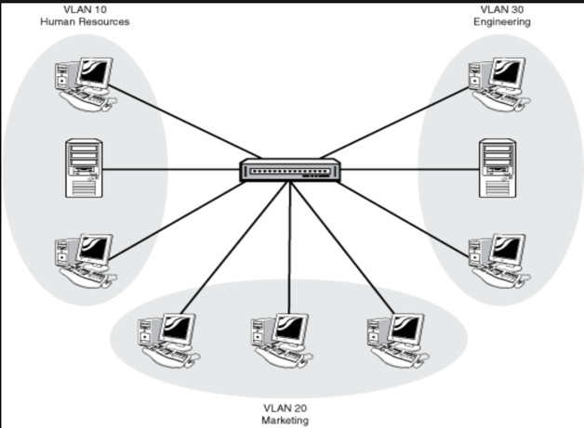A VLAN, or Virtual Local Area Network, is a method of logically segmenting a physical network into isolated virtual networks, allowing network administrators to group devices together based on criteria such as department, function, or security requirements. VLANs operate at the data link layer (Layer 2) of the OSI model and are implemented by assigning VLAN IDs to network frames, typically using 802.1Q tagging. Devices within the same VLAN can communicate with each other as if they are on the same physical network, while communication between VLANs requires a router or a Layer 3 switch. VLANs offer improved network efficiency, security, and flexibility by containing broadcast traffic, isolating communication, and simplifying network management.

Process on Setting up a VLAN network in Cisco Packet Tracer

Step 1: Select a central network device and any type of end-devices. I have chosen a switch

and 16 PC.

Step 2: Create a group of 4pc to set up a VLAN (csit, bca, mbbs, bim).

Step 3: Link every device with the switch.

Step 4: Provide the IP Address to every device and name the connection.

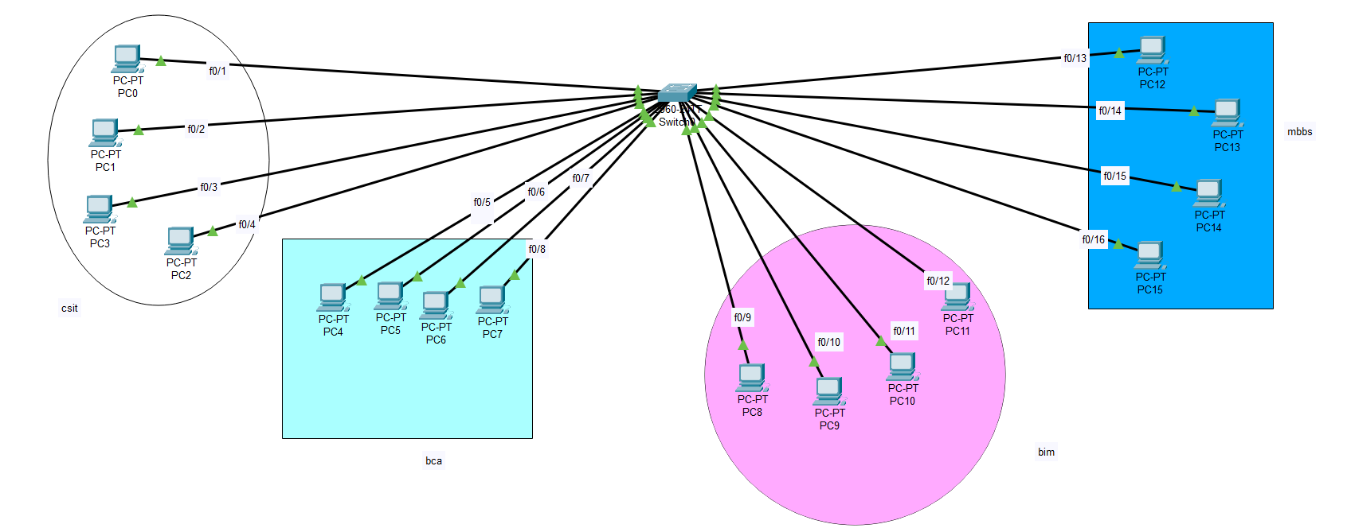

Step 5: Open Switch Command Line Interface and write the following Commands.

COMMANDS:

* Enable
* Configure terminal

After this command we have to set VLAN ID and name for the VLAN.

The command is:  
 # vlan (id_number)

# name (dept_name)

# exit

Follow this command for every department.

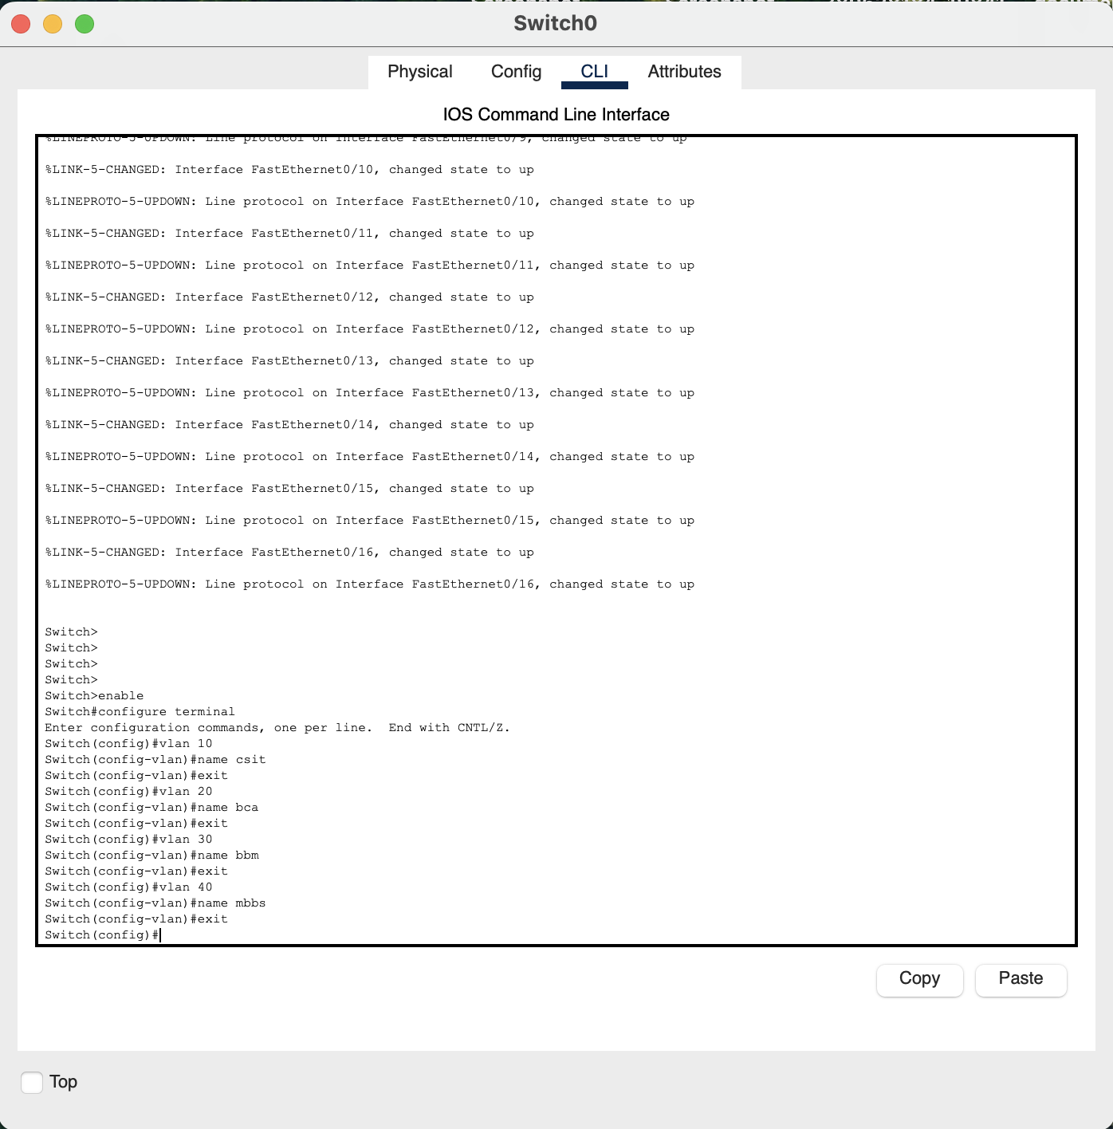

Step 6: Configure an interface by using these commands:

interface <interface_type> <interface_number>

switchport mode access

switchport access vlan <vlan_id>

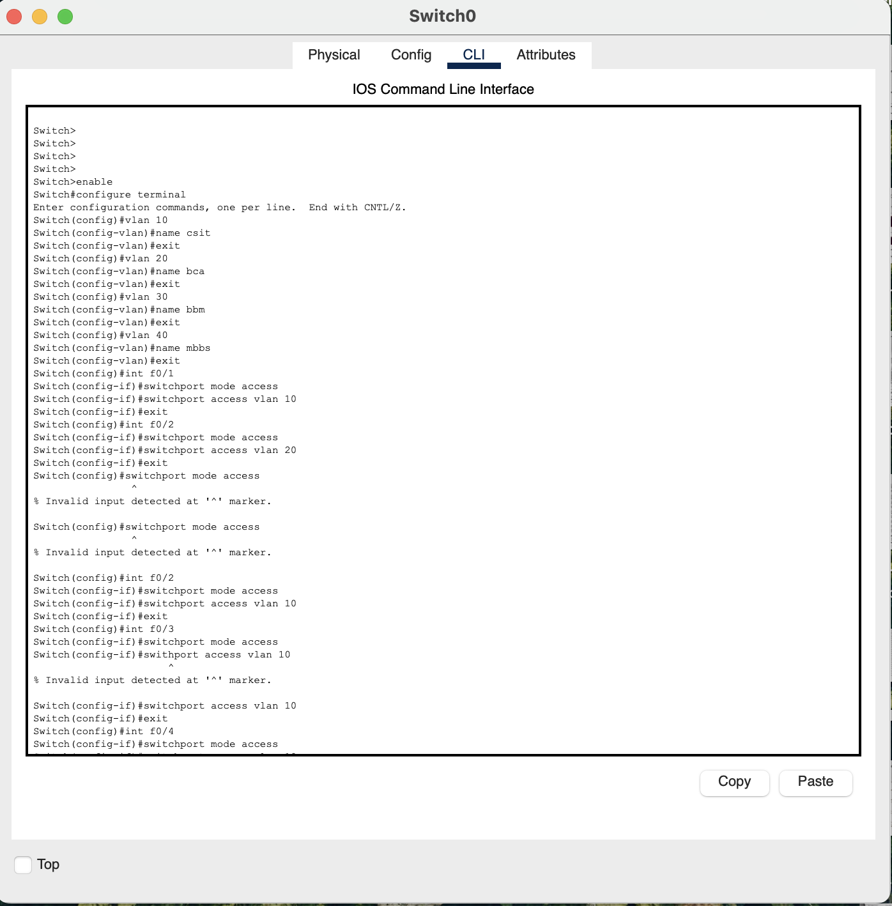

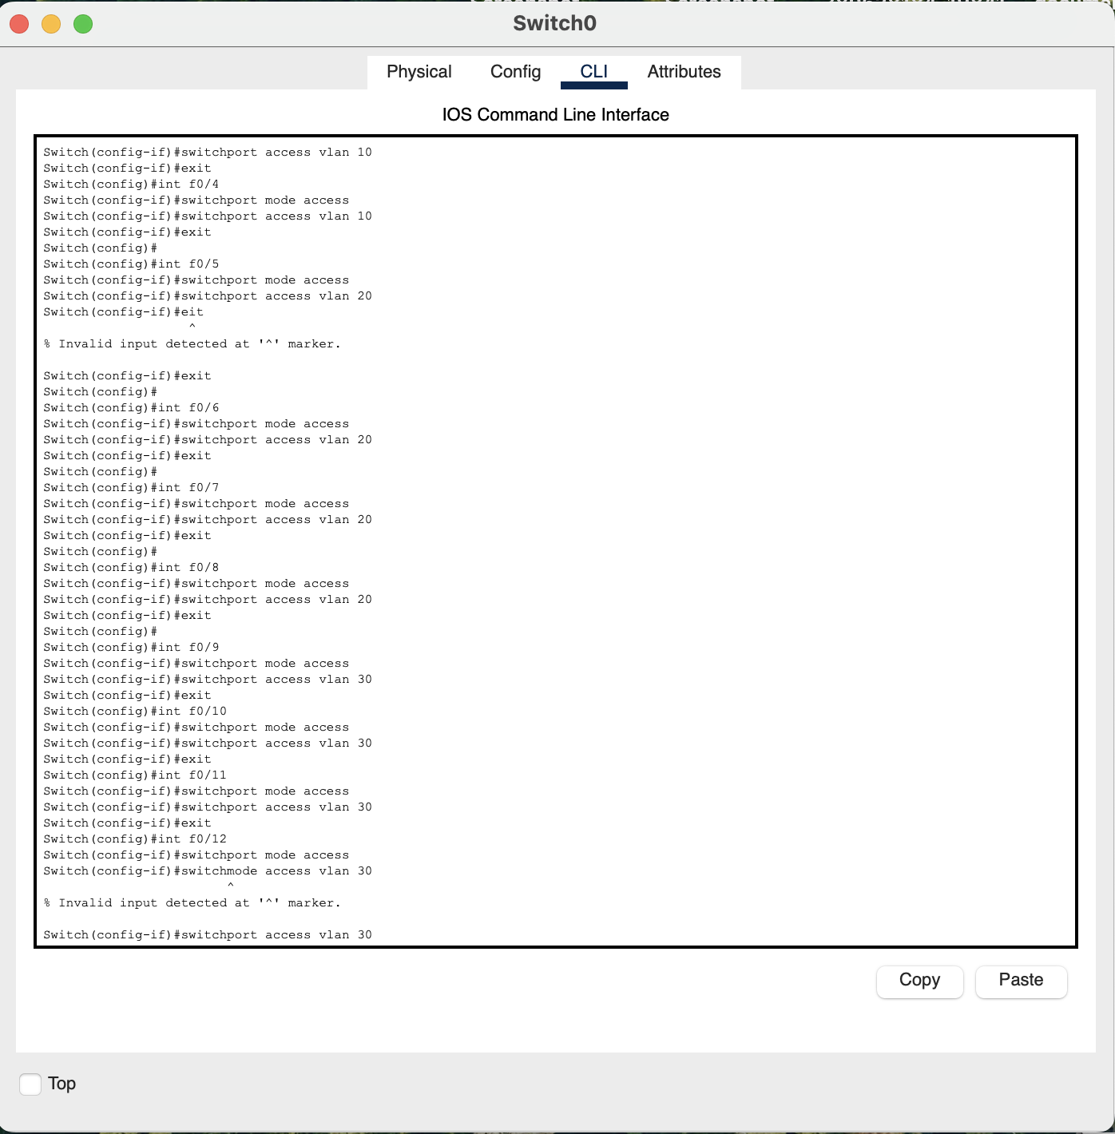

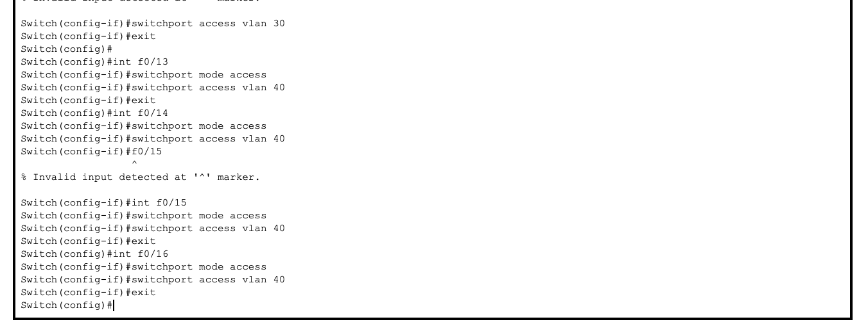

Step 7: Check whether the connections are correct. Here I am trying to ping from csit department computer (192.168.1.2) to same department and another department computer.

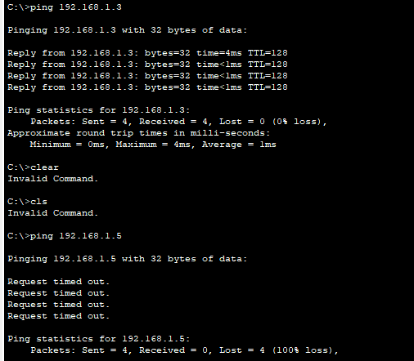



Conclusion:

In this lab, we successfully designed a Virtual Local Area Network (VLAN) for four departments named CSIT, BCA, MBBS, and BIM using a Cisco switch in Cisco Packet Tracer. The aim was to understand the creation of VLANs, IP addressing within the VLAN, and the overall process of setting up a segmented network for improved efficiency and security.